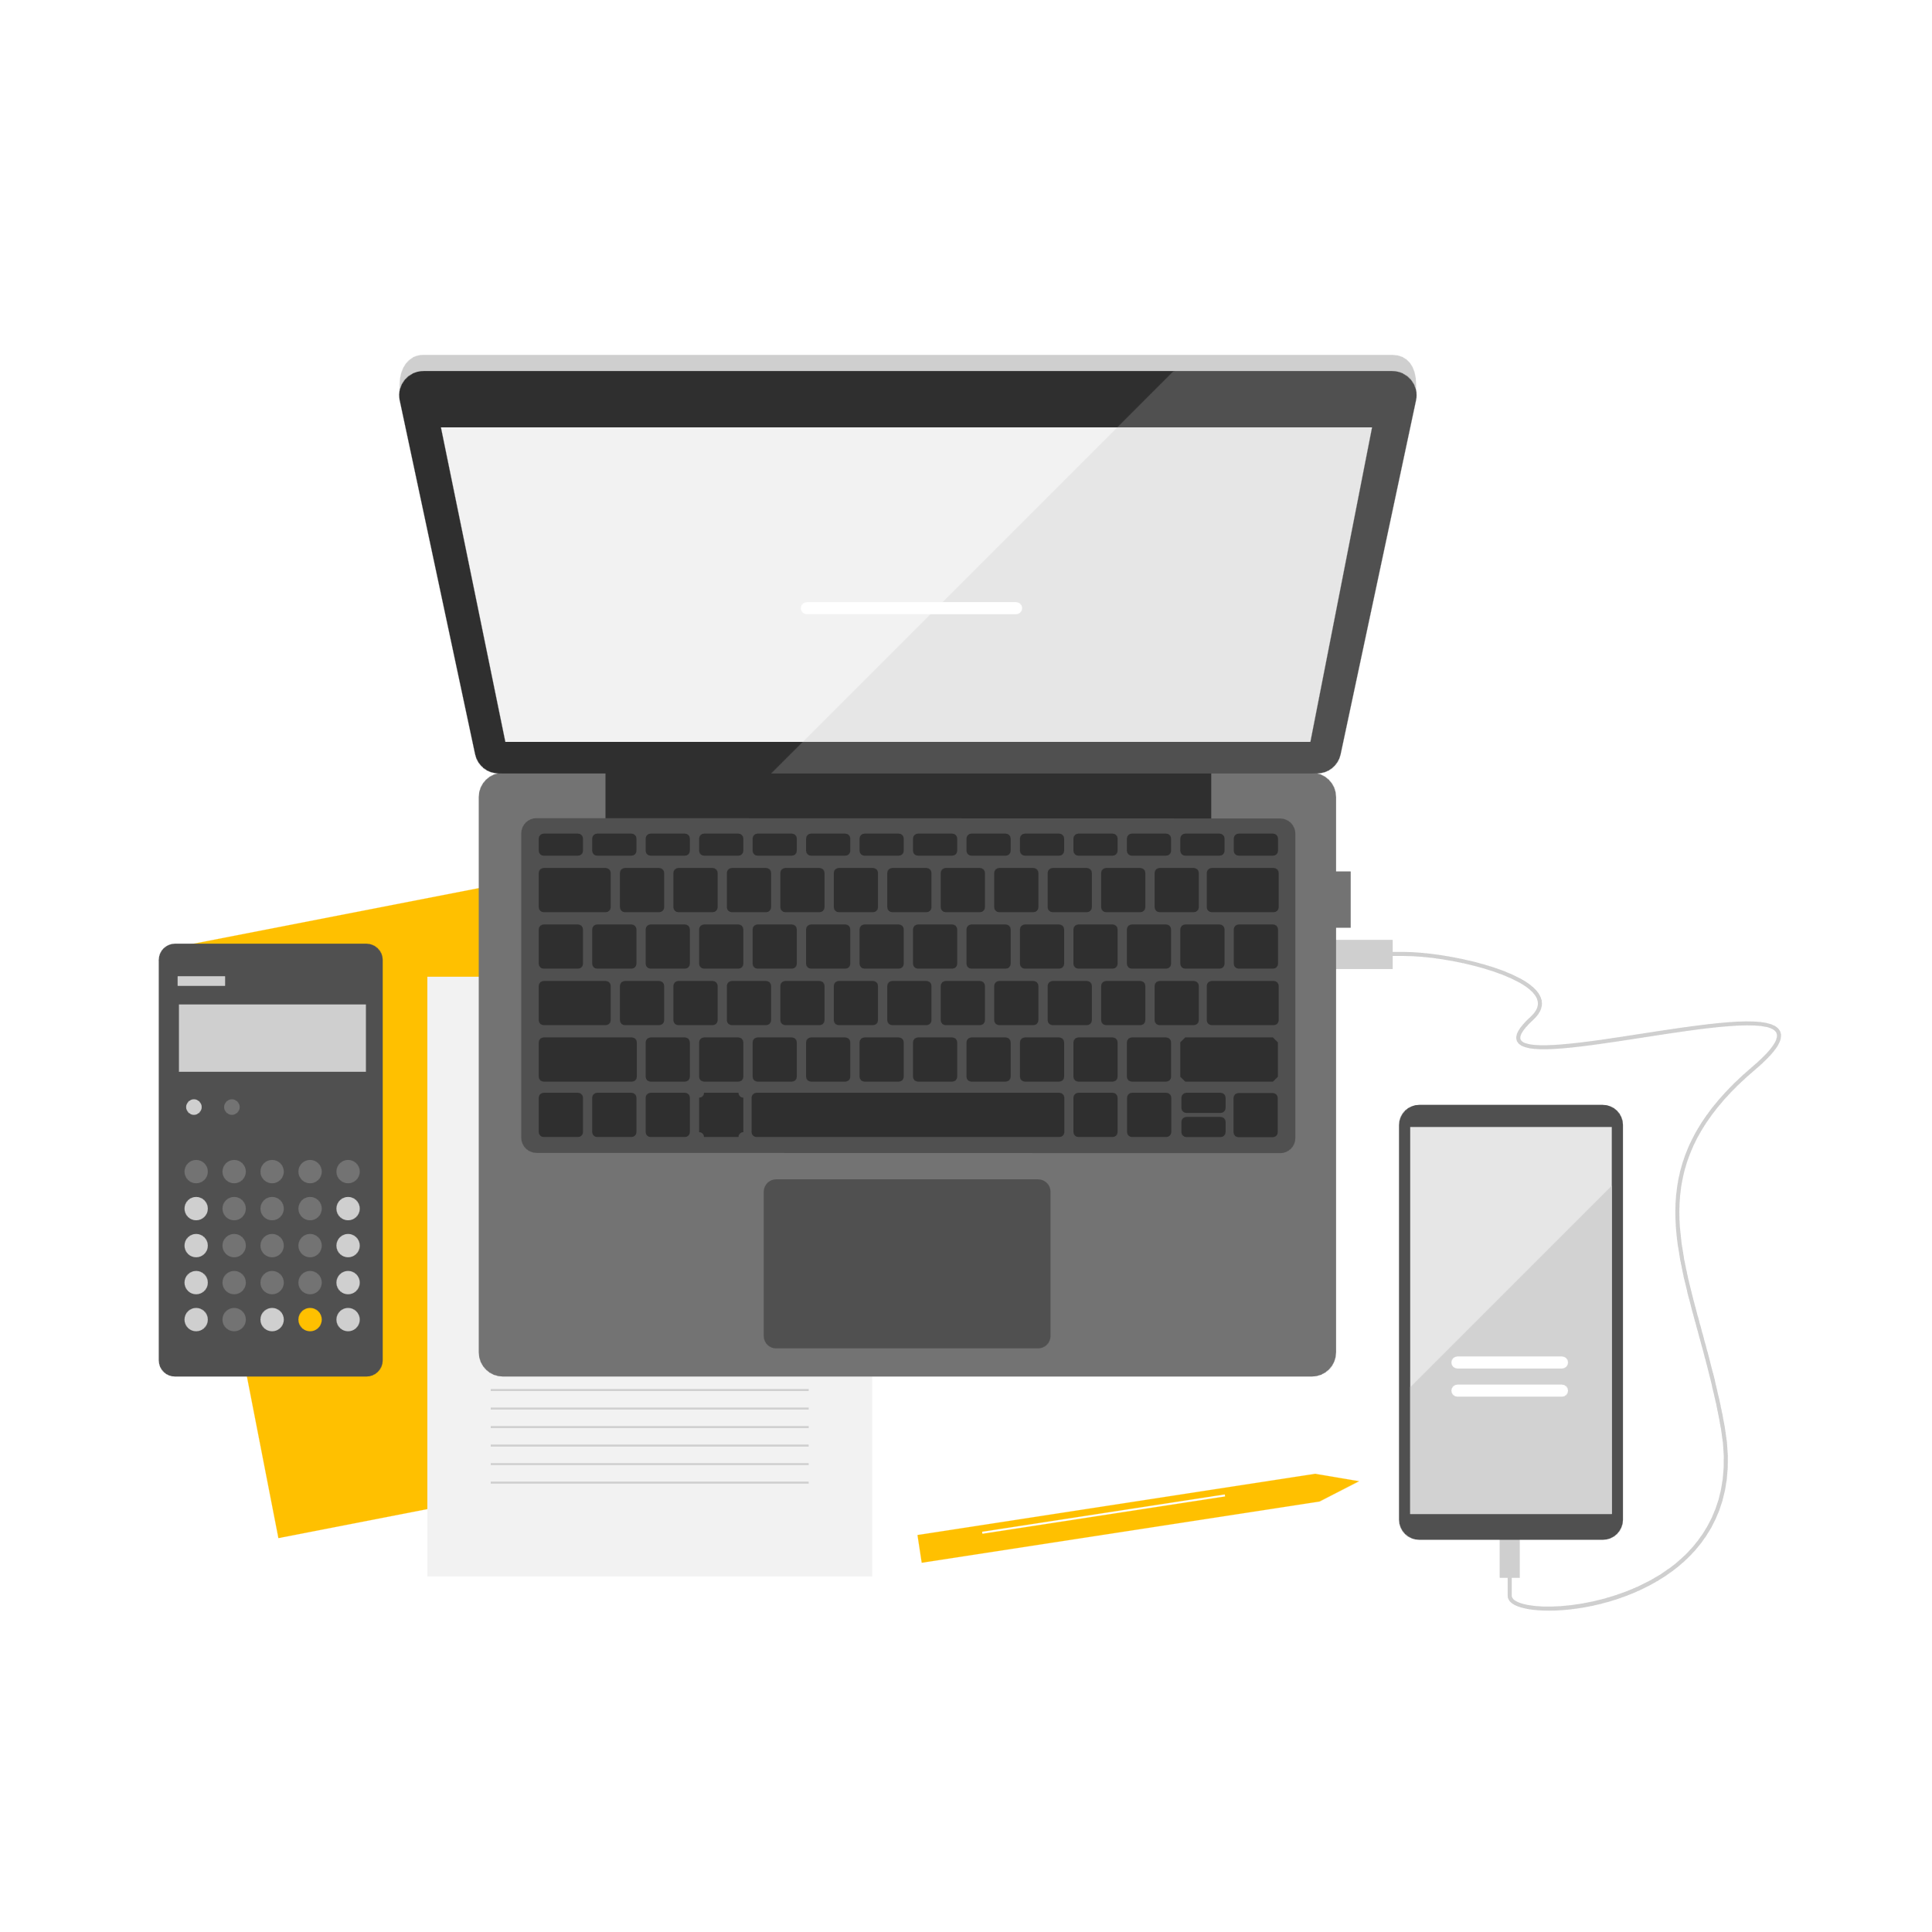

Objective:

To create an IOT in Hospitals for the patients welfare.

Requirements to implement the IOT in hospitals:

Physical Requirements :

Reliable Network Infrastructure:

High-speed, secure, and reliable network connectivity (e.g., Wi-Fi, Ethernet) is essential for IoT devices to communicate with each other and the central system.

Network redundancy and backup systems to minimize downtime in case of failures.

Scalable Architecture:

Hospitals should design their IoT infrastructure to be scalable, accommodating the addition of more devices and sensors as needed.

Power Supply:

Ensure a stable and redundant power supply for IoT devices. Battery-powered devices should have a well-defined maintenance and charging schedule.

Battery power sources, such as uninterruptible power supplies (UPS) or generators, to prevent data loss and device failure during power outages.

Data Security and Privacy:

Implement robust security measures to protect patient data and IoT devices from unauthorized access and cyber threats.

Regularly update and patch IoT devices to address security vulnerabilities.

Comply with healthcare regulations, such as HIPAA (Health Insurance Portability and Accountability Act), to protect patient privacy.

Physical Security:

Protect IoT devices from physical tampering or theft by implementing access controls and surveillance.

Consider using tamper-evident seals or enclosures for critical devices.

Maintenance and Monitoring:

Establish a routine maintenance schedule for IoT devices and sensors to ensure they remain in optimal working condition.

Implement monitoring tools to track the performance of IoT devices and detect issues early.

Environmental Considerations:

IoT devices may be sensitive to environmental conditions. Ensure that they operate within specified temperature, humidity, and other environmental ranges.

Requirement of Engineers to construct IOT in hospitals:

**IoT Systems Architect:**

* Responsible for designing the overall IoT architecture for the hospital, including the selection of sensors, devices, and communication protocols.
* Ensures that the IoT system aligns with the hospital's goals and requirements.

**Network Engineer:**

* Designs and maintains the hospital's network infrastructure to ensure reliable and secure connectivity for IoT devices.
* Implements network security measures to protect against cyber threats.

**Software Developers/Engineers:**

* Develop custom software applications and interfaces for IoT devices to collect, process, and analyze data.
* Create user interfaces for hospital staff and patients to interact with IoT systems.

**Embedded Systems Engineers:**

* Develop and program the embedded software for IoT devices and sensors.
* Ensure that devices operate efficiently and reliably within the hospital environment.

**Data Scientists/Analysts:**

* Analyze the data generated by IoT devices to derive insights that can improve patient care and hospital operations.
* Implement machine learning algorithms for predictive analytics and anomaly detection.

**Cybersecurity Experts:**

* Focus on securing IoT devices and the overall network against cyber threats and vulnerabilities.
* Conduct regular security audits and implement security best practices.

**Cloud Engineers:**

* + Set up and manage cloud-based infrastructure for data storage, processing, and scalability.
  + Ensure data is securely stored and can be accessed by authorized personnel.

**Hardware Engineers:**

* Design and develop custom hardware solutions when off-the-shelf IoT devices do not meet specific hospital requirements.
* Oversee the physical installation and maintenance of IoT hardware.

**Integration Specialists:**

* Ensure seamless integration between IoT systems and existing hospital information systems, such as Electronic Health Records (EHR) and other software applications.
* Develop and maintain data interfaces and APIs.

Project Managers:

* Oversee the entire IoT implementation project, including planning, scheduling, resource allocation, and risk management.
* Ensure that the project stays on budget and on schedule.

Compliance and Regulatory Experts:

* Ensure that the IoT implementation complies with healthcare regulations, such as HIPAA, and industry standards.
* Assist in obtaining necessary certifications and approvals.

Maintenance and Support Teams:

* Provide ongoing maintenance and support for IoT devices and systems.
* Quickly respond to issues and ensure that devices are operational at all times.

User Training Specialists:

* Train hospital staff and patients on how to use IoT devices and systems effectively and safely.

Programming languages to implement the IOT in Hospitals:

Python:

It's commonly used for data analysis, machine learning, and developing backend services.

C/C++:

C and C++ are essential for developing firmware for IoT devices, especially those with resource constraints.

Java:

Java is well-suited for developing Android-based IoT applications, which can be used on smartphones and tablets for healthcare monitoring and data collection.

JavaScript (Node.js):

Node.js, a runtime environment for JavaScript, is used for developing server-side applications in IoT.

SQL and NoSQL Databases:

SQL (e.g., MySQL, PostgreSQL) and NoSQL databases (e.g., MongoDB, Cassandra) are essential for storing and managing IoT data.

R:

R is a language commonly used for statistical analysis and data visualization in healthcare applications, including IoT data.

Ruby:

Ruby and frameworks like Ruby on Rails can be used for developing web-based interfaces and applications that interact with IoT devices.

What is an IOT in Hospital Management ;

* The Internet of Things (IoT) is a network of physical devices that are connected to the internet and can collect and exchange data. IoT devices are already being used in hospitals in a variety of ways
* This data can then be sent to healthcare providers for review, allowing them to detect any problems early on and intervene promptly.
* IoT devices can be used to track the inventory of medical supplies and medications. This data can be used to ensure that hospitals have the supplies they need on hand and to avoid stockouts.
* IoT devices can be used to track the location of medical equipment, such as wheelchairs, defibrillators, and ventilators. This can help hospitals to ensure that equipment is available when and where it is needed, and to reduce the risk of theft or loss.

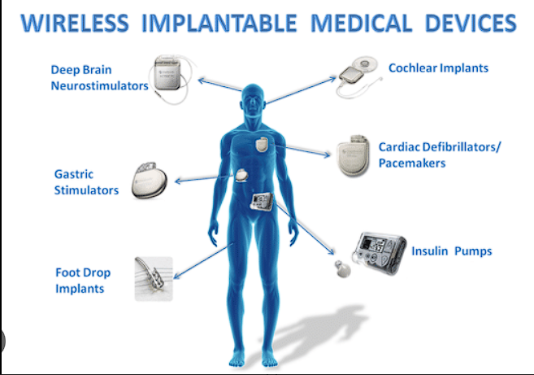

Above is the diagrammatic representation of IOT devices

Purpose of IOT :

To improve patient care:

IoT can help healthcare providers to better monitor patients' health and to provide more timely and effective interventions. For example, IoT devices can be used to remotely monitor patient vital signs, track medication adherence, and provide alerts to caregivers if a patient's condition changes.

To enhance the patient experience :

IoT can help to improve the patient experience by providing more convenient and personalized care. For example, IoT devices can be used to provide patients with access to their medical records, schedule appointments, and communicate with healthcare providers. IoT can also be used to create more comfortable and relaxing hospital environments for patients and their families.

To reduce costs :

IOT can help hospitals to reduce costs by automating tasks, improving efficiency, and reducing waste. For example, IoT-powered sensors can be used to automate tasks such as turning on and off lights, adjusting the temperature, and dispensing medications

Scope of IOT in Hospital Management :

Personalized medicine:

IoT data can be used to develop personalized treatment plans for patients. For example, IoT devices can be used to monitor patients' response to different medications and to track the progression of diseases. This data can then be used to develop treatment plans that are tailored to the individual patient's needs.

Predictive analytics :

IoT data can be used to predict future health events. For example, IoT devices can be used to track patients' vital signs and other health metrics over time. This data can then be used to develop algorithms that can predict when a patient is at risk of a heart attack, stroke, or other health event. This information can then be used to prevent these events from happening in the first place.

Virtual hospitals :

IoT technology could eventually lead to the development of virtual hospitals. Virtual hospitals would allow patients to receive care from healthcare providers remotely. This would be especially beneficial for patients who live in rural areas or who have difficulty traveling to a traditional hospital.

How it satisfies the user needs :

Remote patient monitoring :

IoT devices are being used to monitor patients' vital signs, such as heart rate, blood pressure, and respiratory rate, outside of the hospital setting. This allows patients to receive care from the comfort of their own homes and reduces the need for frequent hospital visits.

Asset tracking :

IoT devices are being used to track the location of medical equipment, such as wheelchairs, defibrillators, and ventilators. This helps to ensure that equipment is available when and where it is needed, and reduces the risk of theft or loss. This can lead to improved patient safety and reduced costs for hospitals.**:**

Environmental monitoring :

IoT devices are being used to monitor environmental conditions in hospitals, such as temperature, humidity, and air quality. This helps to ensure that hospitals are providing a safe and comfortable environment for patients and staff. This can lead to improved patient satisfaction and reduced risk of infections.

Assumption of IOT :

High internet connectivity:

IoT devices require a reliable internet connection in order to function properly. Hospitals must have a robust wireless network in place in order to support IoT devices.

*Cybersecurity*:

IoT devices can be vulnerable to cyberattacks. Hospitals must have strong cybersecurity measures in place to protect IoT devices from being hacked.

Data storage and management:

IoT devices generate a large amount of data. Hospitals must have a system in place to store and manage this data securely and efficiently.

Staff training:

Healthcare staff must be trained on how to use and maintain IoT devices.

Dependcies of IOT :

Interoperability:

IoT devices from different manufacturers need to be able to communicate with each other in order to be effective. Hospitals must choose IoT devices that are interoperable with each other and with their existing IT systems.

Standardization:

There is a need for standards to be developed for IoT devices in healthcare. This will help to ensure that IoT devices are safe, reliable, and easy to use.

Regulation:

Governments need to develop regulations for the use of IoT devices in healthcare. This will help to protect patients and ensure that IoT devices are used in a safe and ethical manner.

Risk involved in IOT :

Cybersecurity risks:

IoT devices are often vulnerable to cyberattacks, which could lead to the theft of sensitive patient data, the disruption of hospital operations, or even physical harm to patients.

Data privacy risks:

IoT devices collect a large amount of data, including personal health information. This data needs to be protected from unauthorized access and use.

Device interoperability risks:

IoT devices from different manufacturers may not be able to communicate with each other, which could limit their effectiveness.

System complexity risks:

IoT systems can be complex and difficult to manage. This could lead to errors and outages.

Cost risks:

IoT solutions can be expensive to implement and maintain. Hospitals need to carefully consider the costs and benefits of IoT solutions before implementing them.

How the risk involved in IOT can be solved:

Cybersecurity:

Hospitals should implement strong cybersecurity measures, such as using strong passwords, encrypting data, and regularly updating security software, to protect their IoT devices from cyberattacks.

Data privacy:

Hospitals should have a data privacy policy in place that outlines how they will collect, use, and store patient data. They should also implement measures to protect patient data from unauthorized access and use, such as data encryption and role-based access control.

Device interoperability:

Hospitals should choose IoT devices that are interoperable with each other and with their existing IT systems. This will help to ensure that the devices can be used effectively and that data can be seamlessly shared between them.

System complexity:

Hospitals should carefully plan and implement their IoT systems to reduce the risk of errors and outages.

Diagrammatic representation for the working principle of IOT devices which plays an vital role in hospital management

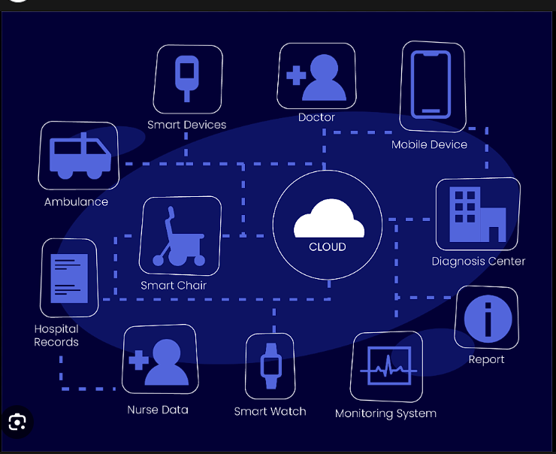

External Interface Requirements of IOT :

Integration with existing hospital systems:

IoT devices need to be able to integrate with existing hospital systems, such as electronic health records (EHR) systems and patient monitoring systems. This will allow data from IoT devices to be easily accessed and used by healthcare professionals.

Interoperability with other IoT devices:

IoT devices from different manufacturers need to be able to communicate with each other. This will allow IoT devices to be used together to create more comprehensive and effective solutions.

Open standards:

IoT devices should use open standards to ensure that they are interoperable and that data can be easily shared between different systems.

Security and privacy:

IoT devices need to be secure and protect patient privacy. This includes using strong encryption and authentication mechanisms.

Scalability:

IoT solutions need to be scalable to meet the needs of growing hospitals.

Usability:

IoT solutions need to be easy to use for both healthcare professionals and patients.

Benefits for poor people by using IOT devices :

* In India, IoT devices are being used to provide remote healthcare services to people in rural areas. For example, the company Aravind Eye Care uses IoT devices to monitor patients' eye health and to provide them with remote consultations with eye doctors. This has helped to improve access to eye care for people in rural areas and to reduce the risk of blindness.
* In South Africa, IoT devices are being used to track the distribution of food aid to poor people. This has helped to reduce corruption and to ensure that food aid is distributed fairly.
* In Brazil, IoT devices are being used to provide poor people with access to clean water. For example, the company Sanepar uses IoT devices to monitor the quality of water in its distribution system and to identify leaks. This has helped to improve the quality of water and to reduce waterborne diseases.
* Improved access to healthcare:

IoT devices can be used to provide remote healthcare services to people in rural areas or who have difficulty traveling to a traditional hospital. For example, IoT devices can be used to monitor patients' vital signs, track their medication adherence, and provide alerts to caregivers if a patient's condition changes. This can help to improve patient outcomes and reduce the risk of complications.

* Reduced healthcare costs:

IoT devices can help to reduce healthcare costs by automating tasks, improving efficiency, and reducing waste. For example, IoT-powered sensors can be used to automate tasks such as turning on and off lights, adjusting the temperature, and dispensing medications. IoT can also be used to track inventory and equipment usage, which can help hospitals to avoid overstocking and to identify areas where costs can be reduced. This can lead to lower healthcare costs for patients, including poor people.

* Improved education:

IoT devices can be used to improve education for poor people. For example, IoT devices can be used to provide students with access to online learning resources and to track their academic progress. This can help students to learn at their own pace and to overcome barriers to education, such as poverty and lack of access to quality schools.

* Increased employment opportunities:

IoT devices can help to create new employment opportunities for poor people. For example, IoT devices can be used to create new jobs in the development, maintenance, and operation of IoT systems. This can help poor people to lift themselves out of poverty and to improve their quality of life.

Conclusion:

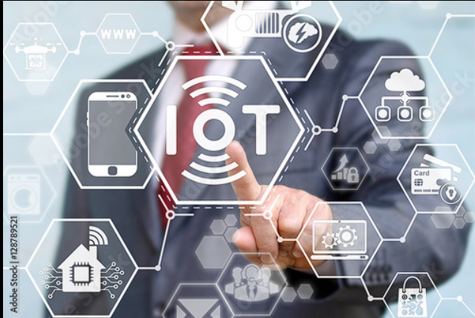

IN FUTURE ENTIRE HOSPITAL MANAGEMENT WILL BE DEPENDENT UPON THE IOT FOR THEIR PATIENT WELFARE AND THEIR GROWTH AND DEVELOPMER

THE SRS DOCUMENT IS COMPLETED BY

* RAGHUL B (TEAM LEADER)
* MELWIN R
* PRASANTH R
* KANISH REDDY C
* SAI KOUSHIK O